Project title: AI Enabled Conversational IVR Modernization Framework - Group 2

Introduction
Interactive Voice Response (IVR) systems have traditionally been built using technologies such as VoiceXML (VXML) to automate customer interactions through structured, menu-driven workflows. While these systems have been effective in handling high call volumes, they often provide limited flexibility and lack the natural, conversational experience that modern users expect.
With the rapid advancement of Conversational Artificial Intelligence (AI), organizations are shifting towards intelligent, context-aware voice interfaces powered by platforms such as Azure Communication Services and BAP Service. These platforms enable natural language understanding, dynamic dialog management, and personalized user interactions.
The AI Enabled Conversational IVR Modernization Framework aims to bridge the gap between legacy VXML-based IVR systems and modern AI-driven conversational platforms. Instead of replacing existing infrastructure entirely, this framework focuses on reusing and extending legacy assets, reducing redevelopment efforts and operational risks. By integrating traditional IVR logic with advanced AI capabilities, the solution enhances usability, improves customer experience, and streamlines the transition to intelligent voice automation.
This modernization approach ensures cost-effectiveness, scalability, and future-readiness, empowering organizations to transform their customer engagement systems while preserving previous investments.

1. Traditional IVR
1.1 What is Traditional IVR?
Traditional Interactive Voice Response (IVR) systems are telephony-based automated systems that interact with callers using predefined menus, DTMF (keypad inputs), and rule-based voice prompts. These systems are commonly built using VoiceXML (VXML) and rely on structured decision trees.
They are widely used in banking, telecom, healthcare, and customer support to handle repetitive queries such as balance inquiries, ticket status, and call routing.

1.2 Traditional IVR Architecture
Traditional IVR systems follow a linear and rule-driven workflow.
Core Components:
- PSTN / SIP Network – Routes incoming calls.
- Telephony Gateway – Connects telecom network to IVR server.
- IVR Application Server – Executes VXML scripts.
- VoiceXML (VXML) Scripts – Define call flow logic.
- ASR (Automatic Speech Recognition) – Converts speech to text (limited grammar-based).
- TTS (Text-to-Speech) – Converts text prompts to voice.
- Backend Systems / Databases – CRM, billing, or enterprise systems.

Traditional IVR Architecture Diagram
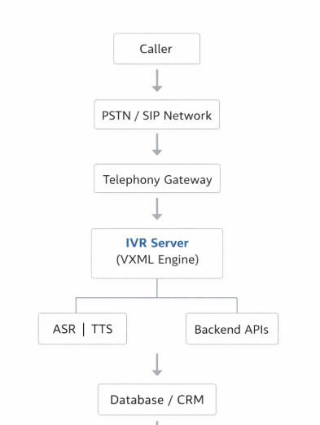

Key Characteristics
- Menu-driven interaction
- Rule-based logic
- Static workflows
- Limited personalization
- Grammar-based speech recognition
- High maintenance for changes

2. Modernized IVR (AI-Enabled Conversational IVR)
2.1 What is Modernized IVR?
Modernized IVR integrates legacy VoiceXML systems with Conversational AI platforms such as:
- Azure Communication Services
- BAP Service
This enables:
- Natural Language Understanding (NLU)
- Context-aware conversations
- Intent detection
- AI-based dialog management
- Omnichannel integration (voice, chat, WhatsApp)
Instead of rigid menu navigation, users can speak naturally (e.g., “I want to check my loan status”).

2.2 Modernized IVR Architecture
Core Components:
- Caller
- Cloud Telephony Layer (ACS)
- Conversational AI Engine
  - NLU Engine
  - Dialog Manager
  - Context Manager
- Legacy VXML Adapter Layer
- Integration APIs
- Enterprise Backend Systems
- Analytics & Monitoring Layer

Modernized IVR Architecture Diagram
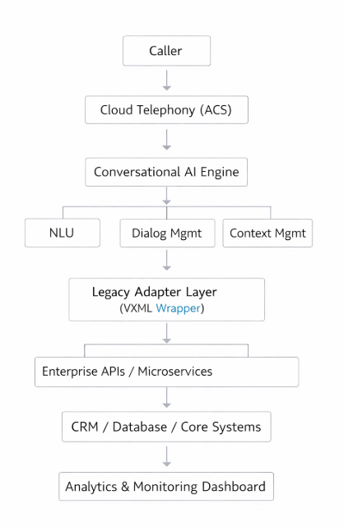

Key Characteristics
- Natural language interaction
- AI-driven dynamic workflows
- Context retention
- Omnichannel support
- API-first architecture
- Scalable cloud deployment

3.Compatibility, Limitations & Feature Comparison
3.1 Limitations of Traditional IVR
Area | Limitation
User Experience | Rigid menu navigation
Flexibility | Hard-coded call flows
Scalability | On-premise dependency
Speech Recognition | Grammar-based only
Integration | Complex API mapping
Personalization | Minimal
Maintenance | High cost for updates

3.2 Compatibility Considerations
When modernizing traditional IVR:
Technical Compatibility
- Existing VXML scripts can be reused via adapter layer
- SIP trunk compatibility required
- Backend APIs must be exposed as REST services
- ASR/TTS engine integration support required
Infrastructure Compatibility
- Cloud-ready or hybrid deployment
- Secure API gateway
- Identity & access management integration
Data Compatibility
- CRM schema alignment
- Logging standardization
- Analytics integration capability

3.3 Features of Modernized IVR
Feature | Traditional IVR | Modernized IVR
Interaction Type | Menu-driven | Conversational
Speech Processing | Basic ASR | AI-powered NLU
Context Awareness | No | Yes
Personalization | Limited | Dynamic
Omnichannel | Voice only | Voice + Chat + Messaging
Analytics | Basic logs | AI insights & dashboards
Scalability | On-prem | Cloud-native
Maintenance | Manual updates | AI-trainable models

Completion of System Analysis
A. Current System Analysis (As-Is)
- VoiceXML-based IVR
- Rule-based decision trees
- Static menu prompts
- Backend system tightly coupled
- High maintenance effort
- Poor customer satisfaction due to long navigation paths

B. Target System Analysis (To-Be)
- Conversational AI interface
- NLU-based intent detection
- Context-aware conversation engine
- Modular microservices architecture
- Cloud telephony integration
- Reusable legacy assets

Workflow Comparison Snapshot
Aspect | Traditional IVR | Modernized IVR
User Input | DTMF / Limited Speech Recognition | Natural Language (Conversational)
Flow Type | Static, Predefined Menus | Dynamic, Adaptive Flows
Intelligence | Rule-Based Logic | AI-Driven Decisioning
Context Handling | No Context Retention | Context-Aware
User Experience | Low (Menu Friction) | High (Personalized & Seamless)

